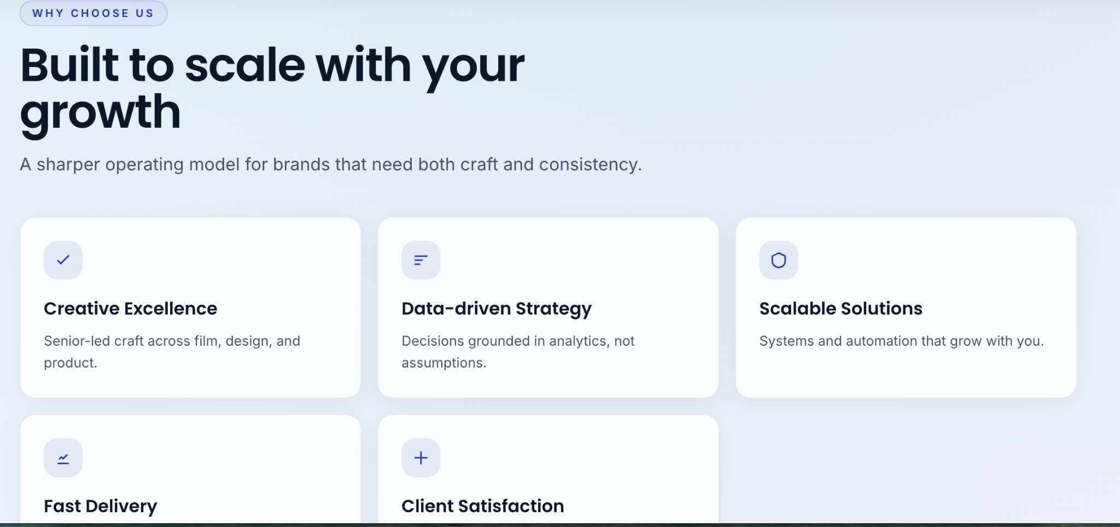
* ei part er likha and execution thik ase but design ta arektu creatives chacchilam, like kono pop-up type or animations.

Design for Existing Section

The text and execution for this section are correct, but the design needs to be more creative. Incorporate elements like a pop-up effect or animations.

2.
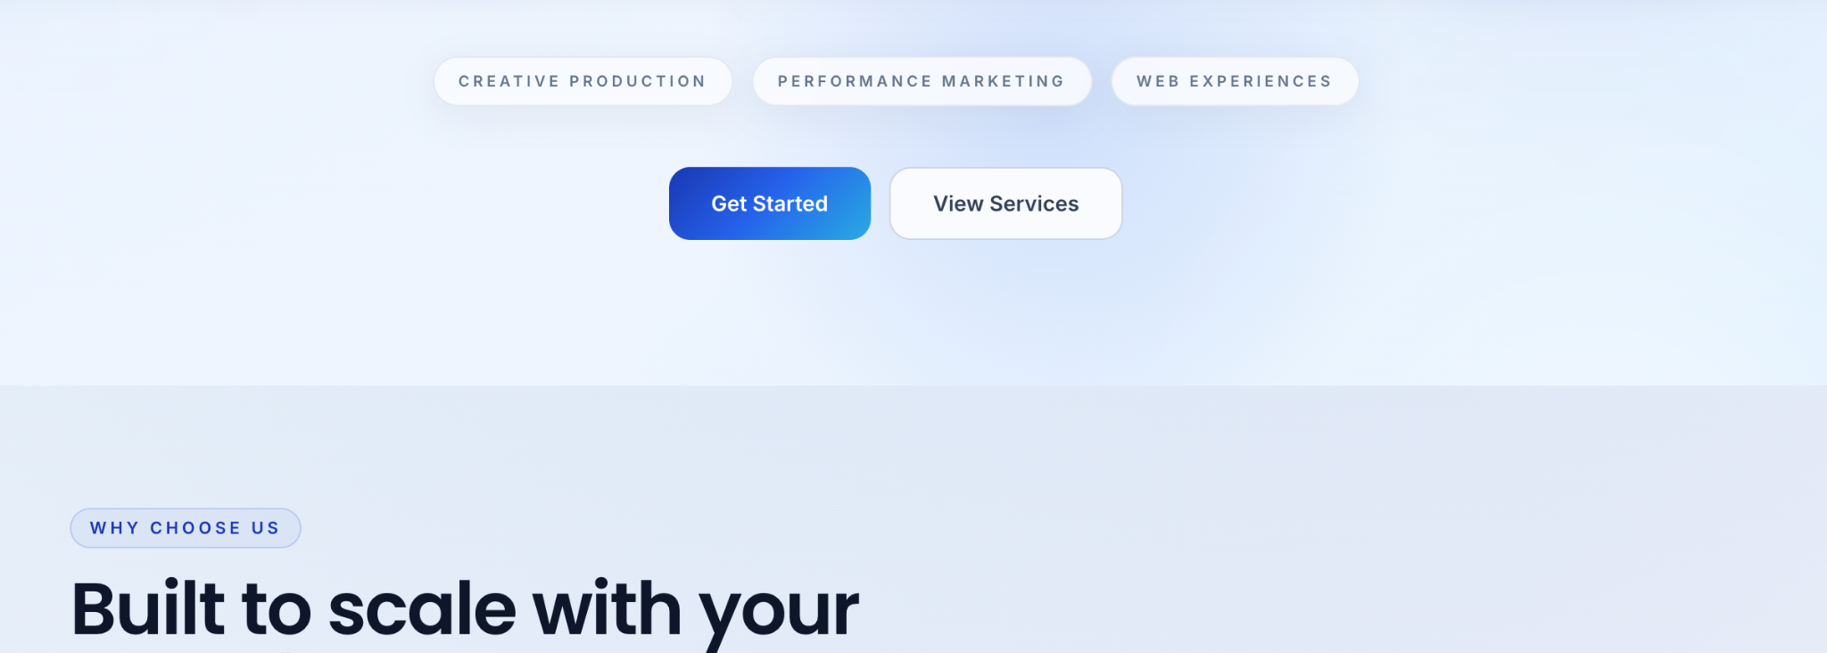
* choose us and get start er majer part e ABOUT US part ta introduce korate chacchilam ⅘ line likha but dekhte jeno boring na lage.

Introduce ABOUT US Section

Introduce a concise ABOUT US section between the "Choose Us" and "Get Start" sections. This section should be visually appealing and contain approximately 4–5 lines of text to ensure it is not boring.

3.
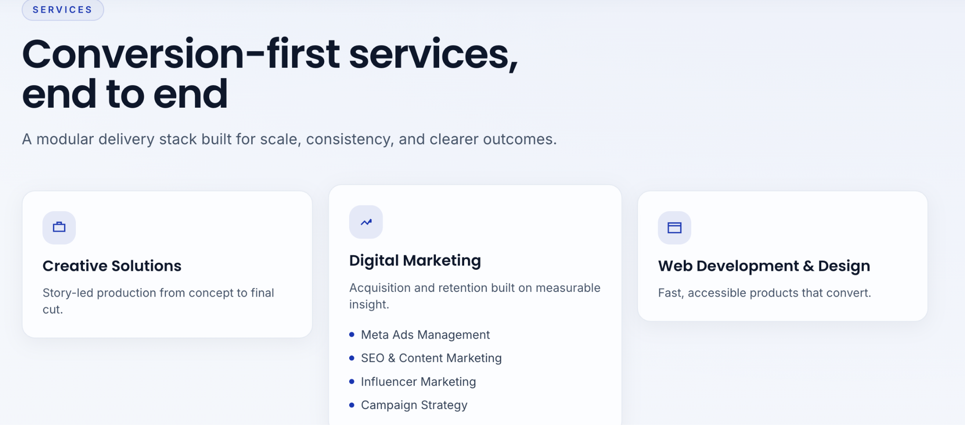

* service part tay - digital marketing, creative solutions niche ss deyar eta click na kore
Mouse ta ei part er upore gele oi sector er under e jei service gulo ase segulo square box er moddhe kore graphics ashbe pore keo click korle direct ei sector er jei service 4 or 5 jegulo ase sobgulo show korbe erpor kono ektar upor click korle details ashbe. Box graphics er upor click na kore mouse gele ASAD er koto emon animation eshe 1 line likha ashbe.

Service Section Interaction (Mouse Hover)

Modify the interaction for service sectors (e.g., Digital Marketing, Creative Solutions) as follows:
- Instead of requiring a click, when the mouse hovers over a service sector, the sub-services under that sector should appear as square box graphics.
1
- If a user clicks on one of these square box graphics, all 4 or 5 services within that sector must be displayed.
1
- Clicking on any of the specific services will then show its details.
1
- When the mouse hovers over the box graphics (without clicking), a specific animation (referencing "ASAD's style") should appear, along with one line of text.
1

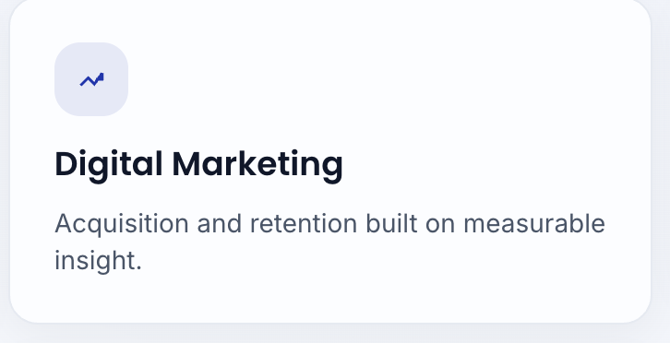

4.
SHOWCASE & PORTFOLIO ei 2 ta part er workings coding kore raikhen but eta ekh publish korbona. Koyekdin por ekhane amadr kaj show kore general kore dibo ekhn jusr ready kore unpublished kore raikhen.

SHOWCASE & PORTFOLIO Sections

Complete the coding and functionality for the SHOWCASE and PORTFOLIO sections, but they must remain unpublished for now. Keep them ready, as they will be published in a few days once we are prepared to display our work.
1

5.
Service er porer part tay eta add kore diyen
video te disilen ein part ta.

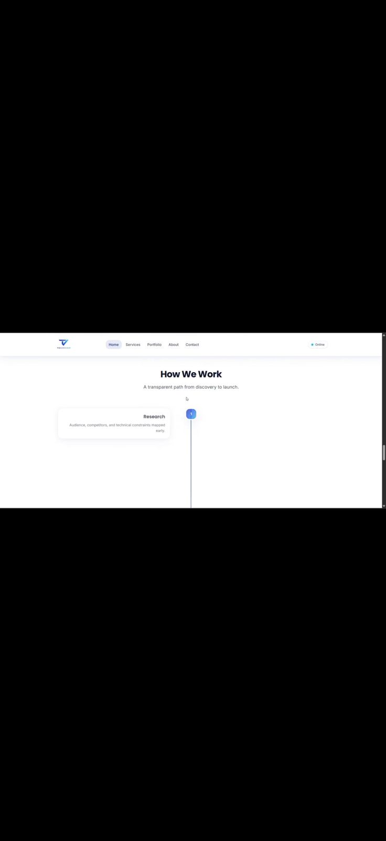
New Section After Service

Add the section that was provided in the video immediately following the Service section.

6.
How we work er porer part e , Who We Are: , Our Story: , Why Tech Viar:
Ending ……..

New Section After Service

Add the section that was provided in the video immediately following the Service section.
1

Sections After How We Work
Following the "How We Work" section, add the following parts, concluding with an ending section:
1
- Who We Are
- Our Story
- Why Tech Viar
- Ending
Other Notes: Section Transition
Implement a custom, stylized transition when navigating from one part of the site to the next (while scrolling down/swiping), instead of using the basic default scroll.
1

ORTHES :
Ek part theke arek part jawar time e (swipe kore niche namar somoy) nekdom basic vabe niche na neme onno kono style.

